

Classic Light Bar
2005-2010 Mustang
Note: Read installation instructions before starting.
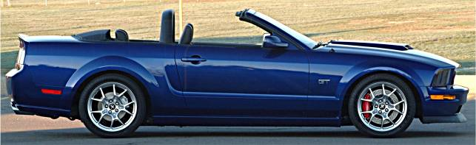
Component List:
- 1 – Light Bar Part #110000
- 1 – Driver Side Bracket w/Set Screw Part #115003
- 1 – Passenger Side Bracket w/Set Screw Part #115004
- 4 – Button Head Screw Part #117000
- 4 – Flange Nut Part #117001
- 2 – 4” Zip-Ties Part #116053
- 1 – CDC Light Bar Wiring Harness Part #05001
- 1 – Light Blue T-Tap Connector (2010 Only) Part #182003
- 1 – Red T-Tap Connector (2010 Only) Part #117032
- 2 – 6” Velcro Strap Part #950009
Tools Required:
⅜” Drive Ratchet Drill Motor
⅜” Drive 3” Extension ⅛” Drill Bit
⅜” Drive 10mm Socket 5/16” Drill Bit
⅜” Drive 13mm Socket 2” Hole Saw
T-50 Torx Bit Trim Tool (Fork Tool)
¼” Allen Wrench Electrical Tape
3/16” Allen Wrench Center Punch
½” Wrench Hammer
Wire Cutter/Stripper Wire Crimper
The Classic Light Bar is NOT intended to provide protection in the event of a rollover.

The Classic Light Bar is Patented: All rights reserved by Classic Design Concepts
- Remove Back Seat:
  - Locate the retainers securing the seat bottom into the vehicle, approximately 10 inches from the end of the cushion, either side. Use your thumb to push in retainer release tab. Lift the seat up to remove.
Figure 1
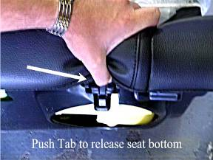
- Remove the two 13mm screws securing the seat back, located on each lower corner. Lift seat upward to release seat back from brackets at the top. You can carefully prop the seat back under the retracted top (see Figure 2 below), use caution if choosing this method not to damage or scratch the vinyl of the seat. You can remove the seat from the vehicle completely by disengaging the flanges securing the top of the rear seat to the fabric of the convertible top well (see Figure 3 below).
Figure 2 Figure 3
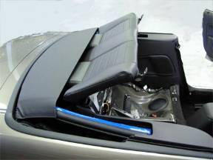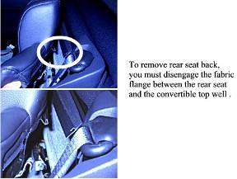
- Remove Quarter Trim Panels:
- Grip the Quarter Trim Panel Cap at the shoulder strap opening and lift up to dislodge the retaining clips.
Figure 4
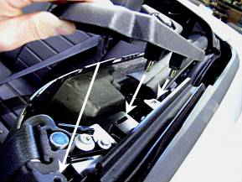

- The inside Quarter Trim Panels are two-piece panels. Remove the upper portion of the Quarter Trim Panel from the vehicle; it is not necessary to remove the lower portion. Pull the forward edge of the trim Panel over the pinch weld in the doorjamb.
Figure 5
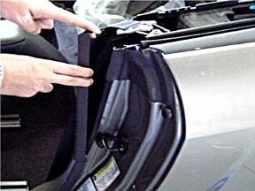
- Use a Door Trim Tool (Fork Tool) to dislodge the pushpin retainer at the rear edge of the Trim Panel approximately 4” down from the top, pry Trim Panel toward the outside of car to release retainer.
Figure 6 Figure 7
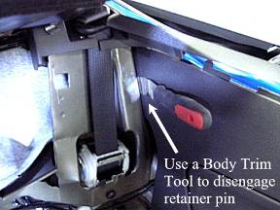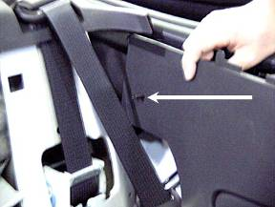
3. Install Light Bar Brackets:
- Remove the shoulder belt guide retaining bolt with a T-50 Torx Bit. Remove the 10mm head bolt directly behind the shoulder belt guide.
Figure 8
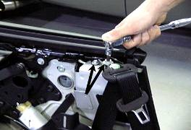
- Install the Light Bar Bracket to the vehicle using the factory bolts removed in the above step.
Note: Factory Seatbelt Bolts are intended only as locators for the Light Bar Brackets, NOT to secure the Brackets. Torque seatbelt guide bolt (T-50 Torx) to 30 lb-ft.
It is imperative that the shoulder strap guide bolt spacer fit inside of the clearance hole of the Light Bar Bracket so that the seat belt functions properly and the Light Bar Bracket fits properly.
- With the Light Bar Bracket in place and secured by the 10mm head bolt and the shoulder strap guide bolt reinstalled and tight, center punch through the two Bracket attachment holes. Drill ⅛” pilot holes through Bracket hole into sheet metal. Enlarge pilot holes to 5/16”.
Figure 9 Figure 10
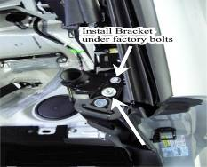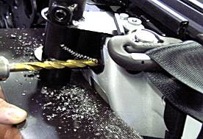
Note: It is very important that you protect the seat belt and the shoulder strap retractor from the cutting debris that is created during the drilling process. We recommend using a magnet to catch the debris.
- Install the Button Head Screws through the Bracket, place nuts on the inside of the body channel, securing Bracket to the vehicle. Tighten Button Head Screws.
Figure 11
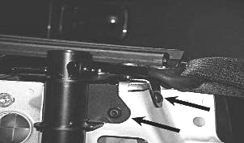
4. Wiring Light Bar LED:
- Locate the plug behind the passenger side quarter trim panel, to the rear of stereo speaker. Remove connector from the sheet metal by dislodging the retainer clip. (Figure 12)
- Locate the factory White Wire with Purple Stripe within the connector. From the wire end of the connector, push the CDC Light Bar LED Wiring Harness #05001 Black wire, pinned end into the same connector opening along side the White/Purple wire. Secure the Black CDC wire to the factory harness with the 4” Zip Tie (CDC #116053). Place Zip Tie immediately behind the shrink wrap on the Black Wire Pin. Tug Black wire to verify that Zip Tie and Pin are secured. We suggest wrapping the CDC wire to the factory wires with electrical tape to provide additional support to the tie in.
Figure 12 Figure 13
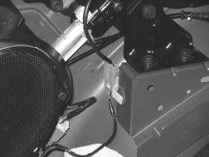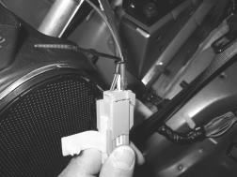
- Route the Connector end of CDC Light Bar Wiring Harness #05001 behind speaker and up through the Light Bar Bracket “A”. Leave Connector end of Harness hang out of the top of Bracket “B”.
B
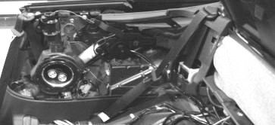
A
NOTE: Secure all wires away from the moving components of the Convertible Top mechanism.
- Trigger Wire Tie-In
2005-
2009 Models: Locate the trunk connector on the passenger side at the hinge. Remove connector from the sheet metal by dislodging the retainer clip. Locate the factory Tan Wire with Blue Stripe within the connector. From the backside of the connector, push the CDC Vehicle Harness #05001 pinned end of Red wire into the same connector opening along side of the Tan/Blue wire. Secure the Red CDC wire to the factory harness with the 4” Zip Tie (CDC #116053). Place Zip Tie immediately behind the shrink wrap on the Red Wire Pin. Tug Red wire to verify that Zip Tie and Pin are secured. We suggest wrapping the CDC wire to the factory wires with electrical tape to provide additional support to the tie in.
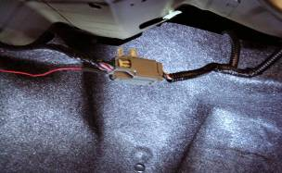
2010 Models: Locate the wire harness on the passenger side leading to the trunk. There is a branch coming from the main bundle that runs outward, this is where you will find the trigger wire. Attach the Red T-Tap Connector (CDC #117032) to the Yellow w/Brown stripe wire. Cut the spade terminal off of the CDC Harness #05001 Red wire, strip end and crimp on the Light Blue Connector (CDC #182003). Plug the Light Blue Connector into the Red T-Tap.
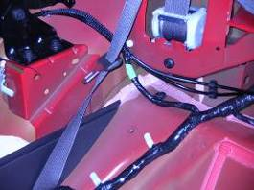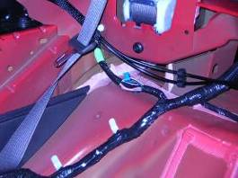
IMPORTANT! 2010 Models Only – The LED will illuminate at approximately 10% of its full output with the top up.

- Temporarily plug Light Bar into Harness and press the brake pedal to verify proper function of LED. If LED doesn’t illuminate when brake pedal is depressed, check your connections at both connections. When verification is complete unplug the Bar from the Vehicle Harness and set aside.
- Reinstall the upper portion of the Quarter Trim Panels on both sides.
    - Cutting holes in Quarter Trim Panel Caps:
- Cutout the Template (supplied in kit) and place on the Passenger Side Trim Panel Cap and align as directed on the Template. Center punch the 2” hole center point, remove the template and drill an ⅛” pilot hole. Follow in the pilot hole with a 2” Hole Saw.
- Flip Template over and place on the Driver Side Trim Panel Cap and repeat the above steps for marking and drilling the 2” hole.
Figure 16
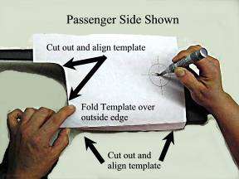
    - Reinstall Quarter Trim Panel Caps:
  - Install the Trim Panel Caps onto their respective sides and verify that the 2” holes drilled in step #4 do not obstruct the Light Bar Bracket receiver tube. If the receiver tube is blocked, trim the Cap as necessary to achieve an unobstructed path for the Light Bar to pass through. The Connector end of the CDC Light Bar Harness MUST extends out of the Bracket to allow for connection to the Bar.
Figure 17
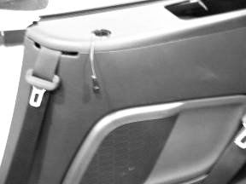
NOTE: Before installing the rear seat, plug the Light Bar into the Harness to verify proper function of LED. If LED doesn’t light when the brake pedal is depressed, check your connections at both connections.

    - Installation of Classic Light Bar:
- Plug the Connector from the LED into the CDC Vehicle Harness installed in the previous steps. Step on brake pedal to verify proper LED function. If LED doesn’t illuminate when the brake pedal is depressed, check your connections at the truck connector then the connector behind the Trim Panel. Push wire down through the Light Bar Bracket receiver tube while lowering the Light Bar ends into the Mounting Brackets.
Figure 18
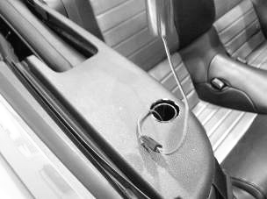
  - Lower Classic Light Bar evenly into Mounting Brackets. Lower Bar down to the tops of Trim Panel Caps. With the bottom of the Light Bar flat on the surface of the trim panel Caps; tighten the Light Bar Bracket Set Screw.
Figure 19
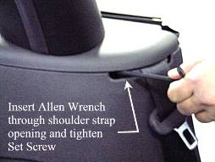

    - Reinstall your back seat:
- Reinstall by reversing step 1.

    - Clearance Convertible Top:
- Cycle the convertible Top to the half-way point. Locate the elastic band that secures the top to the frame at the forward end of the rear window seal.
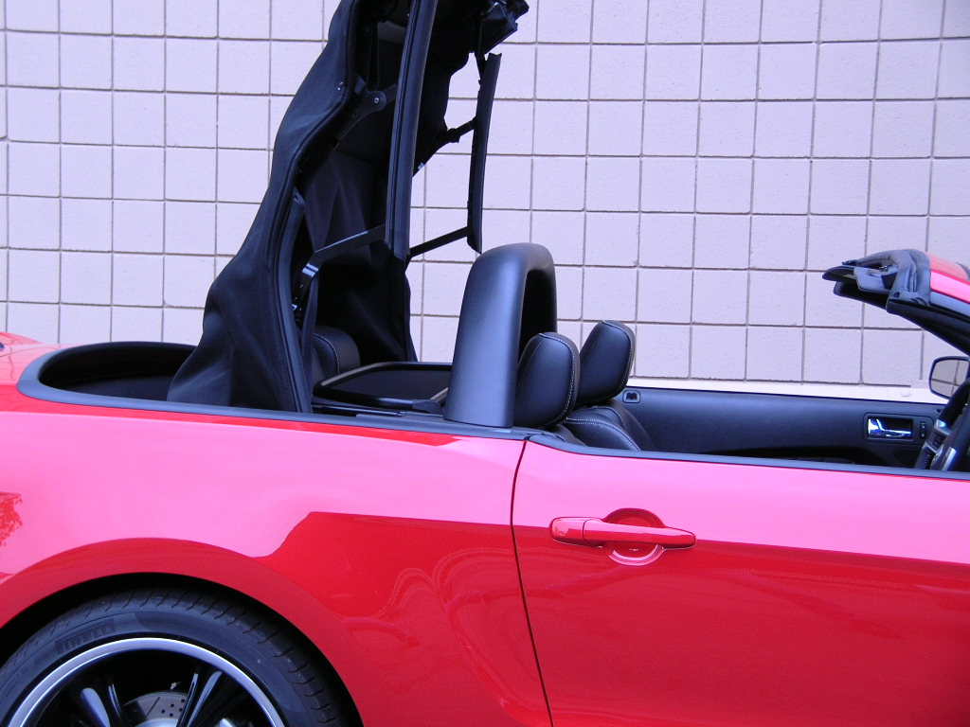
- Use the 6” Velcro straps (CDC # 950009) to draw the elastic band tight. Cross the Velcro Strap around the elastic band. Route the top leg of the Velcro Strap behind the frame. IT IS IMPORTANT THAT THE TOP LEG GO UNDER THE FRAME!
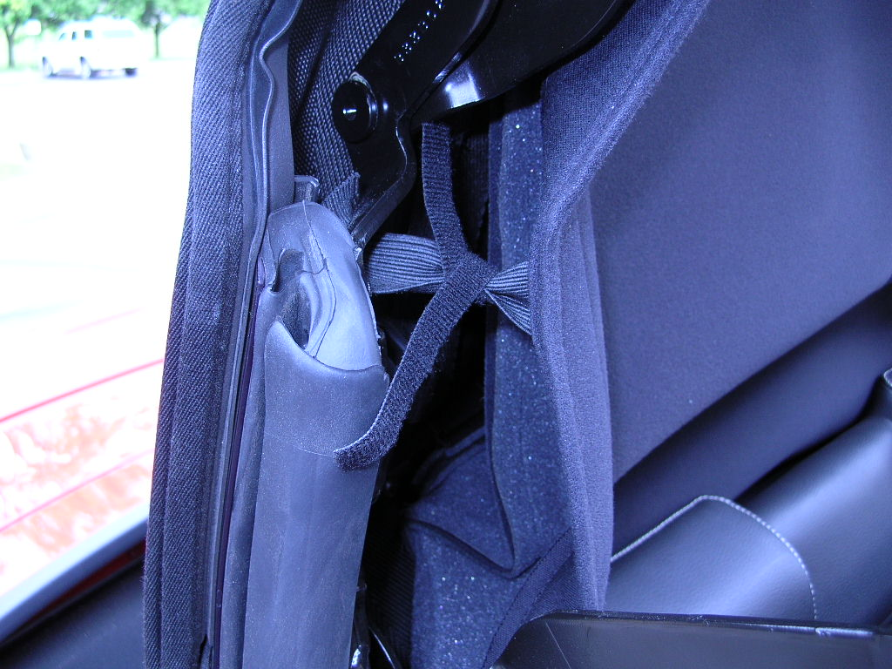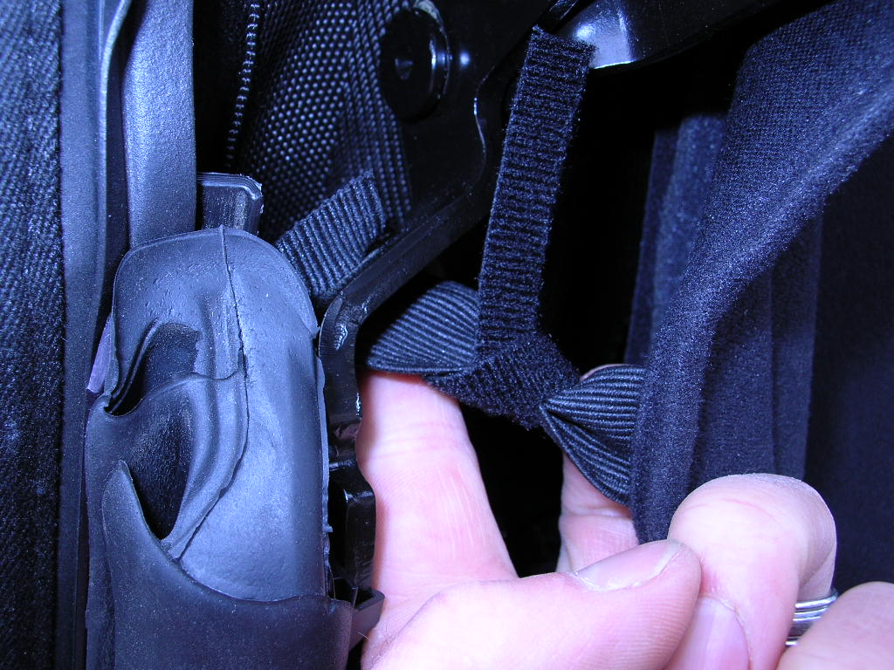
- Wrap the top leg around frame and secure Velcro Strap to the frame with the bottom leg of the Velcro Strap, as shown.

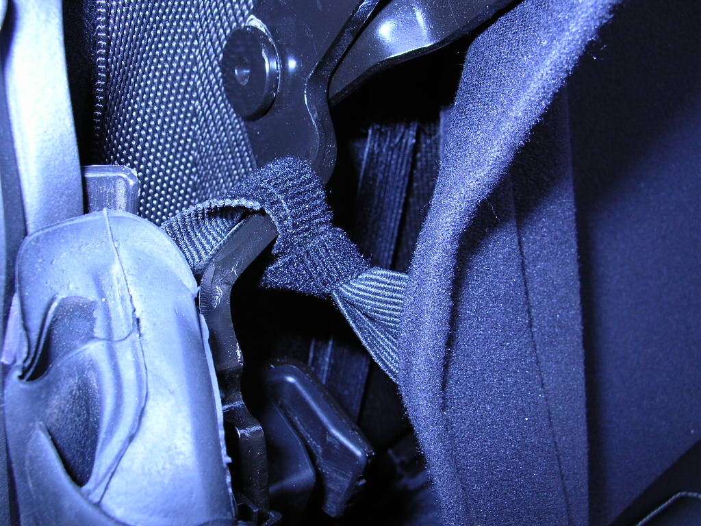
Thank you for choosing Classic Design Concepts for your restyling needs.
If you have any questions or concerns regarding installation please contact
Tech@classicdesignconcepts.com or call 866-624-7997.



